

International School

API Integration Plan Document
Course: System Integration Practices
Project Title: Integrated HR & Payroll Dashboard System for Company X
Case Study 2: Models Integration
Version: 1.0
Date: 15/4/2026
Group: Group 5
Semester: 2 – Academic Year 2025–2026
Instructor: MSc. Nguyen Dang Quang Huy
Team Members:
Name | Student ID
Manh, Nguyen Van Duy | 29211100024
Loc, Tran Viet | 29211352994
Tin, Huynh Tran | 29211358847
Loi, Tran Van | 29211159367
Viet, Dang Dai | 29211155820

Approved by
MSc Huy, Nguyen Dang Quang
Da Nang 05/2026
Project Acronym | HRD
Project Title | Company X – Integrated HR & Payroll Management Dashboard
Start Date | 15 April 2026 | End Date | 20 April 2026
Lead Institution | International School, Duy Tan University
Role | Name | Email |  | Phone
Project Mentor | Nguyen Dang Quang Huy | huyndq@duytan.edu.vn |  | 0935525354
 | Nguyen Van Duy Manh | duymanhdnvn1@gmail.com |  | 0779534325
 | Tran Viet Loc | tranvietloc288@gmail.com |  | 0365957050
 | Huynh Tran Tin | trantin202ad@gmail.com |  | 0899565751
 | Tran Van Loi | tvl19012005@gmail.com |  | 0898238541
 | Dang Dai Viet | vdang9721@gmail.com |  | 0384165721

DOCUMENT NAME
Document Title | API Integration Plan Document
Reporting Period | 17– April - 2026
Author(s) | Tran Viet Loc
Role | Developer
Date | 17/04/2026 | File name | 5. API Integration Plan.docx

DOCUMENT APPROVALS
Document Approvals: The following signatures are required for approval of this document.
Mentor | Huy, Nguyen Dang Quang | Signature:
 |  | Date:
 |  | Date:
Team member(s) | Manh, Nguyen Van Duy | Signature:
 |  | Date:
 | Loc, Tran Viet | Signature:
 |  | Date:
 | Tin, Huynh Tran | Signature:
 |  | Date:
 | Loi, Tran Van | Signature:
 |  | Date:
 | Viet, Dang Dai | Signature:
 |  | Date:

TABLE OF CONTENTS
1. Introduction 6
1.1 Purpose 6
1.2 Scope 6
1.3 System Overview 7
2. Integration Objectives 7
3. Integration Architecture Overview 8
3.1 High-Level Architecture 8
3.2 Data Flow Diagram 8
4. API Design Plan 9
4.1 API Standards 9
4.2 API Endpoints 10
4.3 Sample API JSON Structures 11
4.4 Error Handling & Rollback Strategy 12
4.4.1 Error Classification 12
4.4.2 Error Handling Rules 13
4.4.3 Rollback Strategy 13
5. Data Mapping Reference 14
6. Security Considerations (Design Level) 15
7. Integration Testing Plan (Design Outline) 16
8. Deliverables and Next Steps 16
9. References 17

1. Introduction

1.1 Purpose
- This API Integration Plan Document is developed to define the architecture, standards, and list of Application Programming Interfaces (APIs) that serve as intermediaries connecting two independent systems of Company X: the Human Resources system (HUMAN_2025 - SQL Server) and the Payroll system (PAYROLL - MySQL).

- This document serves as a detailed technical blueprint helping the backend development team (API Developers) understand the data flow, request/response structure, and error handling (rollback) mechanisms needed to implement the actual source code in Case Study 3.

1.2 Scope
The scope of the integration plan includes:
- Data Synchronization (Sync): Automatically synchronize changes to Employees, Departments, and Positions from the HR system to the Payroll system.
- Data Retrieval (Read-only): Provide APIs for the Dashboard to retrieve attendance data, salary history, and dividends.
- Reporting & Alerts: Aggregate data from both databases to support the export of management reports and the generation of automated alerts (overtime leave, work anniversaries).
- Out of Scope: This phase only designs the API structure and synchronization logic; advanced security encryption beyond the planned JWT authentication mechanism is not yet implemented. The existing table structure of the two original databases will not be modified.

1.3 System Overview
System | Database Type | Primary Tables | Role in Integration
HUMAN | SQL Server | EMPLOYEE, DEPARTMENT | Source system for HR data
PAYROLL | MySQL | PAYROLL, SALARY_DETAIL | Destination for payroll calculation

2. Integration Objectives
Objective | Description
O1. Data Synchronization | Ensure data consistency by automatically synchronizing employee records, departments, and positions from SQL Server to MySQL in real-time.
O2. Unified API Connectivity | Build a single Middleware (API Layer) providing standard RESTful endpoints so the Dashboard can communicate with both systems.
O3. Transactional Integrity | Ensure data integrity through Transaction and Rollback mechanisms when updates across the two different databases encounter errors.
O4. Centralized Security | Establish a separate security mechanism using JWT and RBAC, without interfering with the internal security of the legacy databases.

3. Integration Architecture Overview

3.1 High-Level Architecture
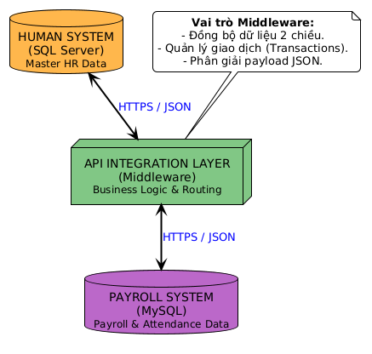

Data Flow Diagram
3.2.1 Các thành phần chính trong DFD
Tên thành phần | Mô tả
Dashboard (React) | User interface that sends HTTP Requests (with JWT token) to request data or issue update commands.
API Integration Layer | Intermediate backend service. Receives requests, authenticates, queries the corresponding databases, and maps data back to the Dashboard.
HUMAN System (SQL Server) | Handles CRUD commands related to original records. Transmits Employee data stream to API.
PAYROLL System (MySQL) | Receives synchronized Employee data stream from API for storage. Provides Salary/Attendance data stream back to API.
3.2.2 Sơ đồ luồng dữ liệu mức tổng quan
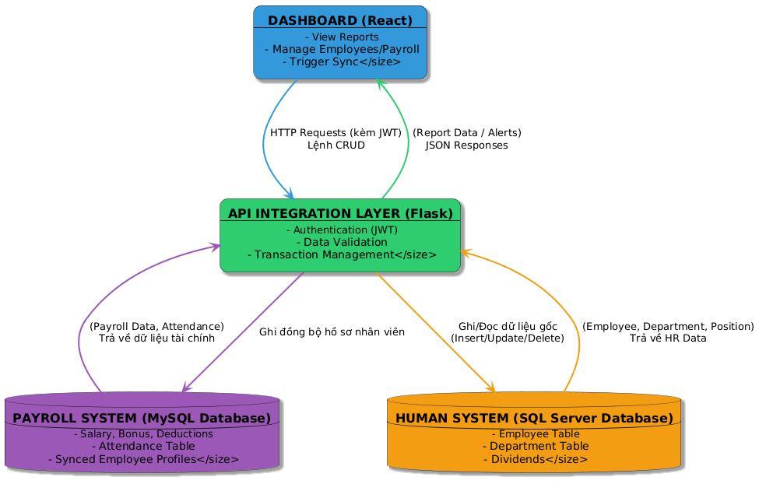

4. API Design Plan

4.1 API Standards
- Protocol: HTTPS / RESTful.
- Data Format: JSON (application/json).
- Authentication: Bearer Token (JWT) transmitted via Header.
- Naming Convention: Use lowercase plural nouns (e.g., /api/v1/employees).
- Standard HTTP Status Codes:
- 200 OK (Successful retrieval)
- 201 Created (Successfully created)
- 400 Bad Request (Invalid input data)
- 401 Unauthorized (Token error)
- 409 Conflict (Data constraint violation / Duplicate)
- 500 Internal Server Error (System/DB error)

4.2 API Endpoints
No. | Method | Endpoint | Description | Source/Target
1 | GET | /api/v1/employees | Get list of personnel (filter by department/status) | SQL Server → Dashboard
2 | POST | /api/v1/employees | Add new employee & auto-synchronize | SQL Server → MySQL
3 | PUT | /api/v1/employees/{id} | Update employee information & synchronize | SQL Server → MySQL
4 | DELETE | /api/v1/employees/{id} | Delete employee (with salary/dividend constraint check) | SQL/MySQL ↔ API
5 | GET | /api/v1/departments | Get department list | SQL Server → Dashboard
6 | POST | /api/v1/departments | Add/Update department & synchronize | SQL Server → MySQL
7 | GET | /api/v1/payroll | Retrieve monthly payroll list | MySQL → Dashboard
8 | GET | /api/v1/payroll/{id}/history | Retrieve salary history for one employee | MySQL → Dashboard
9 | GET | /api/v1/attendance | Retrieve aggregate attendance data | MySQL → Dashboard
10 | GET | /api/v1/reports/hr | Get HR statistical report data | SQL Server → Dashboard
11 | GET | /api/v1/alerts | Get list of automated alerts (leave, anniversaries) | SQL/MySQL → Dashboard

4.3 Sample API JSON Structures
Example: Add New Employee API (POST /api/v1/employees)
Request Header: Authorization: Bearer <token>
Request Body:
{ "FullName": "Tran Van A", "DateOfBirth": "1995-05-12", "Gender": "M", "Email": "tranvana@companyx.com", "PhoneNumber": "0901234567", "HireDate": "2026-05-01", "Status": "Active", "DepartmentID": 101, "PositionID": 201 }

Response Body (Success - 201 Created):
{ "status": "success", "message": "Employee created and synchronized successfully.", "data": { "EmployeeID": 5042, "FullName": "Tran Van A", "DepartmentName": "IT" } }

4.4 Error Handling & Rollback Strategy

4.4.1 Error Classification
Error Type | Brief Description | Example
Connection Error | API cannot connect to the target DB. | "Timeout connecting to PAYROLL MySQL."
Authentication Error | JWT Token expired or wrong Role. | "401 – Unauthorized / 403 - Forbidden."
Validation Error | Missing required fields, incorrect format. | "400 - FullName is required."
Conflict Error | Foreign key violation, duplicate ID. | "409 - Cannot delete employee with salary records."

4.4.2 Error Handling Rules
Error Scenario | System Action | Response JSON
Delete employee with existing salary data | API Layer blocks the DELETE query execution. | { "status": "failed", "code": 409, "message": "Constraint violated: Employee has salary records." }
SQL Server write successful but MySQL fails | Trigger Rollback: Delete the newly created record in SQL Server, write log. | { "status": "failed", "code": 500, "message": "Sync to Payroll failed. Transaction rolled back." }

4.4.3 Rollback Strategy
Step 1: Record Temporary Operation (Temporary Record)
- When the API performs synchronization (e.g., adding a new employee), the data will be temporarily stored in the SYNC_TEMP table.
- Only when both systems have successfully updated will this record be changed to the 'Success' status.
Step 2: Detect Error and Trigger Rollback (Rollback Trigger)
- If the API receives an error from either system (e.g., PAYROLL returns a 'Duplicate Emp_Code' error),
- The system will automatically delete the data just added on the other side (if any), or mark the temporary record as 'Failed'.
Step 3: Error Logging (Error Logging)
- All errors are stored in the SYNC_LOG table with: API name, error, timestamp, rollback status.
- If automatic rollback fails, the technical team will perform manual handling based on records in SYNC_LOG.
Objective:
- Ensure no scenario where data is only updated in one system.
- HUMAN and PAYROLL data remains consistent after each synchronization.
Sample SYNC_TEMP Table (temporary write before confirming success)
TempID | EmployeeID | ActionType | Status | CreatedAt
T1001 | E123 | Insert | Pending | 2025-10-21 10:22:11
T1002 | E124 | Insert | Failed | 2025-10-21 10:30:05

Sample SYNC_LOG Table (error & rollback logging)
LogID | APIName | ErrorMessage | RollbackFlag | CreatedAt | Resolved
L1001 | /api/v1/employees/sync | PAYROLL insert failed (duplicate ID) | 1 | 2025-10-21 10:31 | 0

5. Data Mapping Reference
The Request/Response API design is based on the original data mapping schema. Below is a summary of the mappings. (For details, see the document 6. Database Design – Data Mapping.docx).
Employee Mapping:
- SQL Server (Employees): EmployeeID (PK), FullName, Status, DepartmentID, PositionID
- MySQL (employees_payroll): EmployeeID (PK), FullName, Status, DepartmentID, PositionID
- Synchronization Direction: SQL Server → MySQL (Real-time via API).
Payroll Mapping (Read-only for Dashboard):
- MySQL (salaries): Retrieve BaseSalary, Bonus, Deductions, NetSalary. Linked to HR via EmployeeID.
Attendance Mapping (Read-only):
MySQL (attendance): Retrieve WorkDays, LeaveDays, AbsentDays. Used for API Alerts.

6. Security Considerations (Design Level)
- Authentication Database: A separate database will be used to manage Dashboard access accounts, ensuring no interference with the original business databases.
- JWT (JSON Web Token): All requests to the API Layer must include a valid JWT in the header. Tokens have an expiration time.
- RBAC (Role-Based Access Control):
- HR Manager: Can call POST/PUT/DELETE APIs related to Employee/Department.
- Payroll Manager: Can call payroll calculation APIs, cannot delete employees.
- Employee: Can only call GET API to view their own profile and salary history (with ID match check).

7. Integration Testing Plan (Design Outline)

Test ID | API Endpoint | Test Objective | Expected Result
T01 | POST /api/v1/employees | Test new employee synchronization. | Returns 201. Employee appears in both SQL Server and MySQL.
T02 | DELETE /api/v1/employees/{id} | Test deleting an employee with salary history. | Returns 409 Conflict. No deletion recorded.
T03 | GET /api/v1/payroll/{id}/history | Test accurate salary history retrieval. | Returns 200 with detailed JSON array of salary records.
T04 | GET /api/v1/alerts | Test alert logic for employees exceeding leave days. | Returns list of employees with LeaveDays exceeding the policy.

8. Deliverables and Next Steps
Related documents in Case Study 2 include:
- Software Requirements Specification (SRS) Document
- Data Mapping Document
- UI/UX Design Mockups
- API Integration Plan Document (This document)

Next Steps:
The next phase (Case Study 3) will use this document as a design foundation to carry out actual programming (Implementation) of the APIs using a Backend language, establish database connections, write synchronization logic, and run Unit Tests according to the outlined plan.

9. References
- System Integration Practices Lecture Notes – MSc. Nguyen Dang Quang Huy, Case Study 1 & 2 Guidelines (2025).
- Company X – CEO Memo (2025).
- Business Requirement Document (BRD) - Group 5.
- Software Requirements Specification (SRS) - Group 5.
- Database Design – Data Mapping Document - Group 5.

